Chapter 10, Problem 65.

Using Fig. 10.108, design a problem to help other students better understand Norton’s theorem.
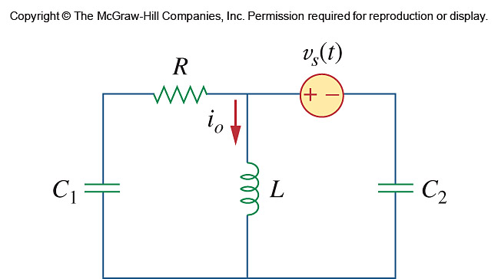

Figure 10.108
For Prob. 10.65.

